|  |  |
| --- | --- |
| PROJECT ID: PNT2022TMID23131 | SOLUTION ARCHITECTURE |

**DOMAIN:** IoT

**Project Title:** Smart Farmer – IOT Enabled Smart Farming Application

**Team Members**:

1)Afrin Jumana M (913119106005)

2)Srinithi A(913119106109)

3) Jeeva Getzie Cynthia A (913119106038)

4)Priya M(913119106079)

**SMART FARMER-IOT ENABLED SMART FARMING APPLICATION**

The proposed solution will assist farmers by getting live data (Temperature, humidity, soil moisture) from the farmland to take necessary steps to enable them to do smart farming by also increasing their crop yields and saving resources (water, fertilizers).

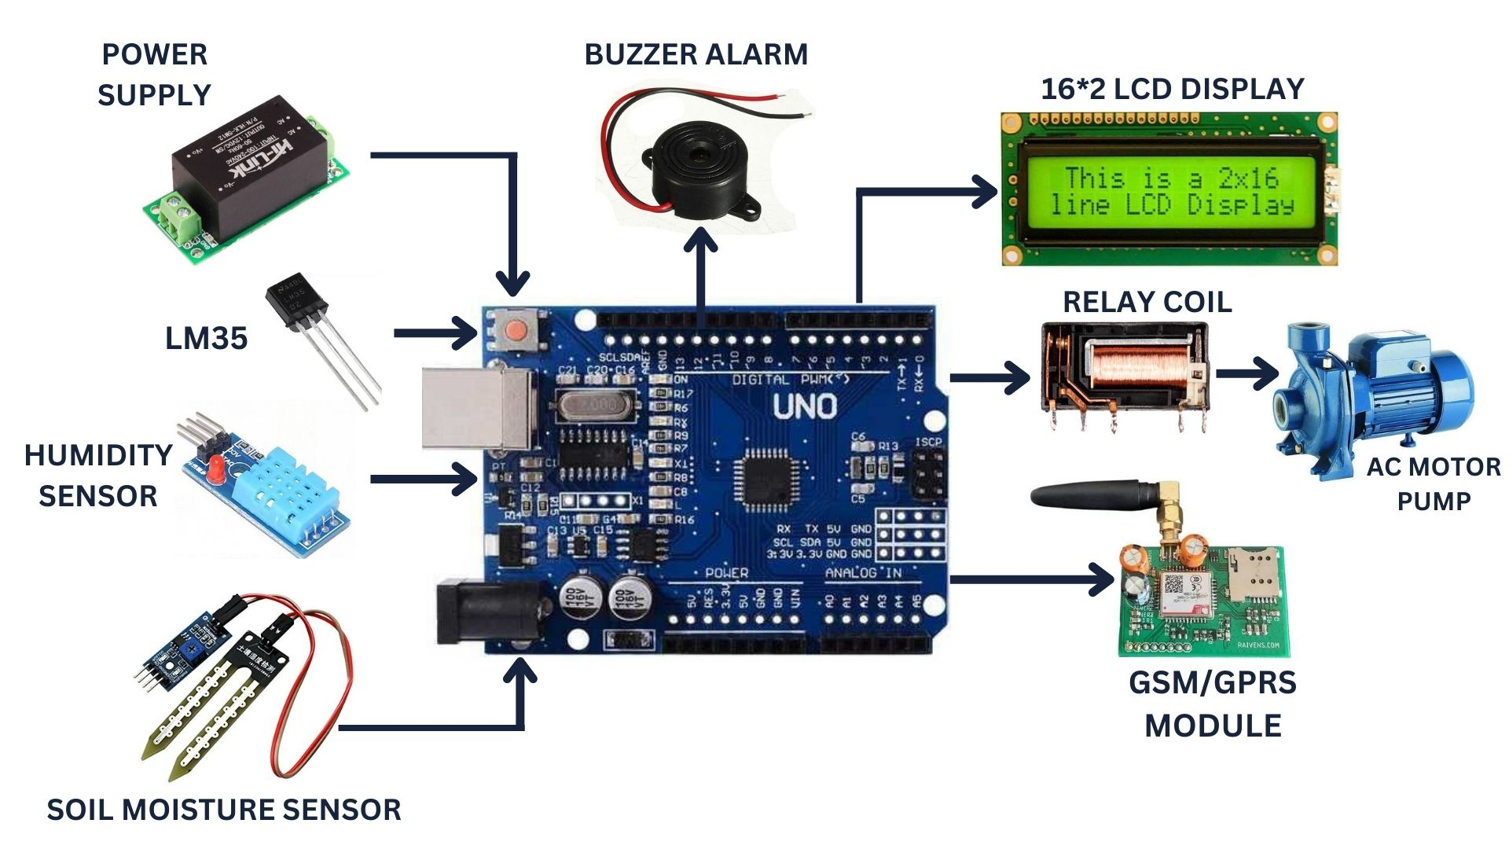

The architecture of proposed system consists of various blocks:

**SENSORS**

The soil moisture sensor senses the moisture level in the soil. The humidity and temperature sensor gives the humidity and temperature values of the atmosphere which determine whether the crop is suitable for growth. The soil moisture sensor, humidity and temperature sensor continuously monitors the soil and environmental conditions, sends the live data to mobile.

**ARDUINO UNO**

Arduino Uno is the heart of the system. The facts gathered with the aid of the sensors is sent to the Arduino UNO.The gathered information may be displayed in a Arduino IDE.

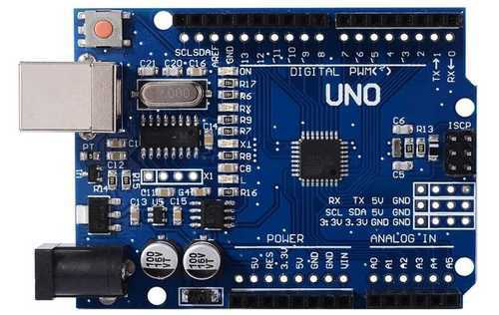

**SOIL MOISTURE SENSOR**

A soil moisture sensor empowers agriculturalists to estimate the water levels without the need to be physically present in the field.

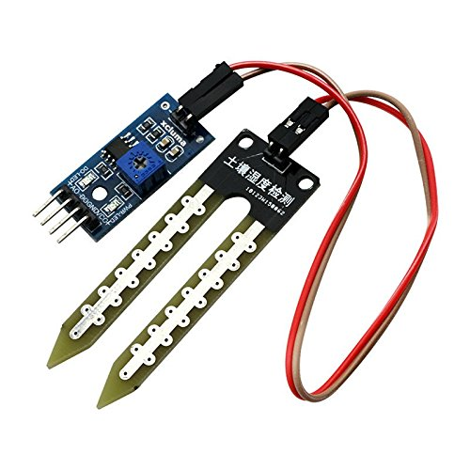

**TEMPERATURE SENSOR**

The temperature sensor senses the surrounding temperature of the farm in different farm conditions.

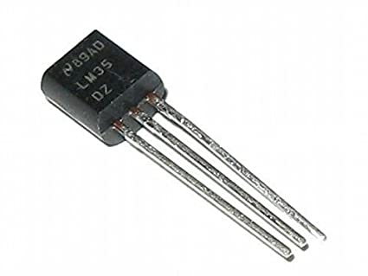

**HUMIDITY SENSOR**

Humidity sensors are electronic devices that measure and report the moisture and air temperature of the surrounding environment.

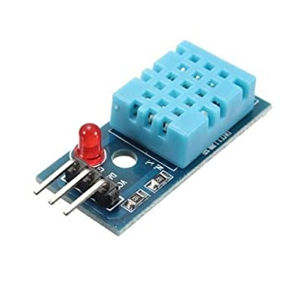

**GSM/GPRS MODULE**

A GSM module is hooked up with the Arduino to facilitate messaging service which updates the farmer present climatic conditions of the subject. GSM module is used to sending a message to the owner of farm after comparison output is positive or negative. If output is positive then wild animal detected then message send to the owner of farm using GSM.

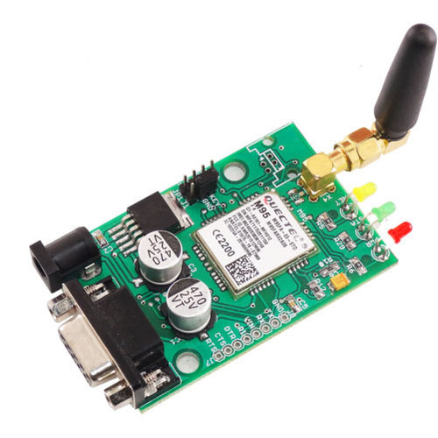

**BUZZER ALARM**

The project system can capture the image. This is to ward off the animals from fields. An buzzer is introduced, Its loudly audible to animals. The buzzer switched on automatically only after animals are detected in the farm.

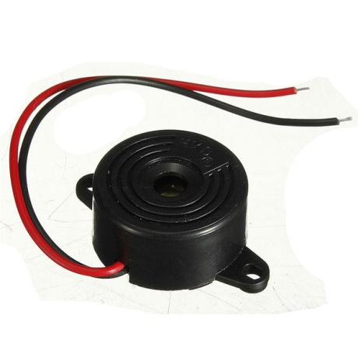

**AC MOTOR PUMP**

This pump willpump water from well and water is sent to the farmland.

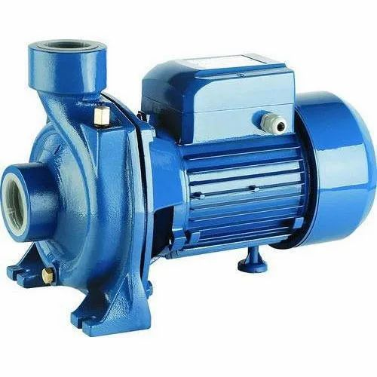

**16*2 LCD DISPLAY**

A LCD display is used to display the functioning of the project at any given time.

